First Semester Progress Report of Nasrat II School Project
Prepared by Nadia Usafzai
Edited by M. Israr
Funding provided by Rotarians in Canada and the Canadian International Development Agency to the La Jolla Golden Triangle Rotary Club Foundation

Teacher Training:
The 30 days teacher training session for the Nasrat II School started in January 2012. And 16 teachers from gard1 to 4 participated in this training. The training was focused mainly on Reading, Writing and Mathematics and effective teaching methodology and lesson plan preparation. During this training the teachers were also trained on how to manage classrooms, motivate students and avoid physical punishment. The teachers were also trained on how to use teaching materials like charts, flash cards, balls, blocks as well as the locally and naturally available materials such as small stones, leaves and so forth. During the training the teachers were encouraged to engage students in various activities such as group work, peer work and other social activities.
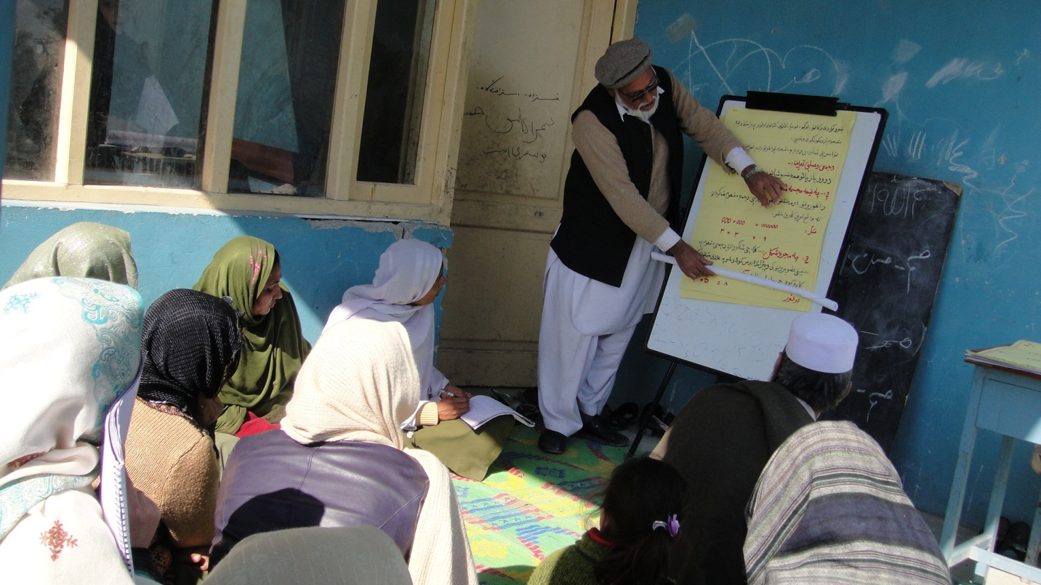
The trainees are trained on how to effectively teach Maths to lower grade students
Lesson Plan:
One of the most important topics covered during the training was Lesson Plan Development. The teachers practically worked on lesson plan development for almost one week. This one week long session gave opportunity to the teachers to develop one general lesson plan template so that all the teachers can use it during their classes.

Teaching Session:
The practical teaching in classes started in February 2012. The teachers were assigned to develop lesson plans for one week and should submit it to the project monitor. The project director, project manager and the concern teacher who developed the lesson plan would review the lesson plans and bring necessary changes. The approved lesson plans were given to the teachers so that they can come with a lesson plan to class every day. And at the end of the day the project monitor collected lesson plans and filed them for record. This strategy, forced/encouraged the teachers to come prepared to the class and use the lesson plan. At the beginning, the teachers seemed to be not happy and the lesson plan was a kind of burden, but later on the teachers adopted it as daily routine and found the lesson plan as a useful tool for teaching. Miss Mahjbeen 3rd grade teacher said “The lesson plan helps me better teach in class, it reminds of what to cover in the class and how to teach it”.

Teaching Materials:
This first time in Nasrat II School that students use some teaching materials. These materials include flash cards, blocks, various charts, various size balls and various size color stickers. Using teaching materials changed the class from teacher centered to learner-centered where students are actively involved in learning process.

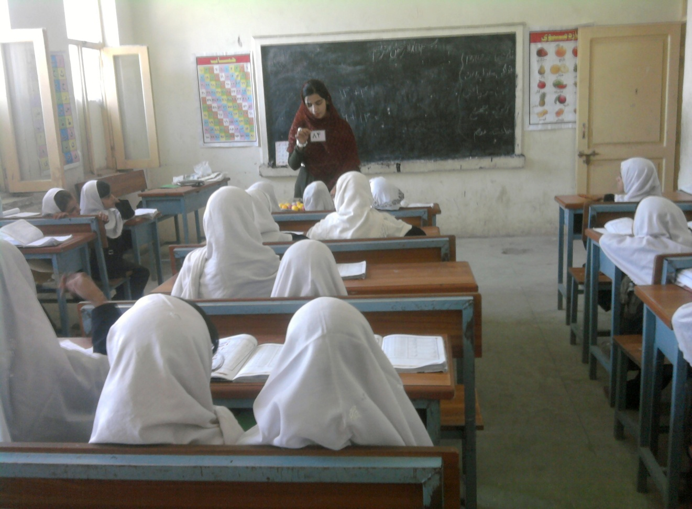
Miss Saima 1st grade teacher uses flash cards and charts during her math class.

The use of teacher materials changed classes from passive to active ones and the students learn while having fun. It also provides some tension free time in the class to the students.

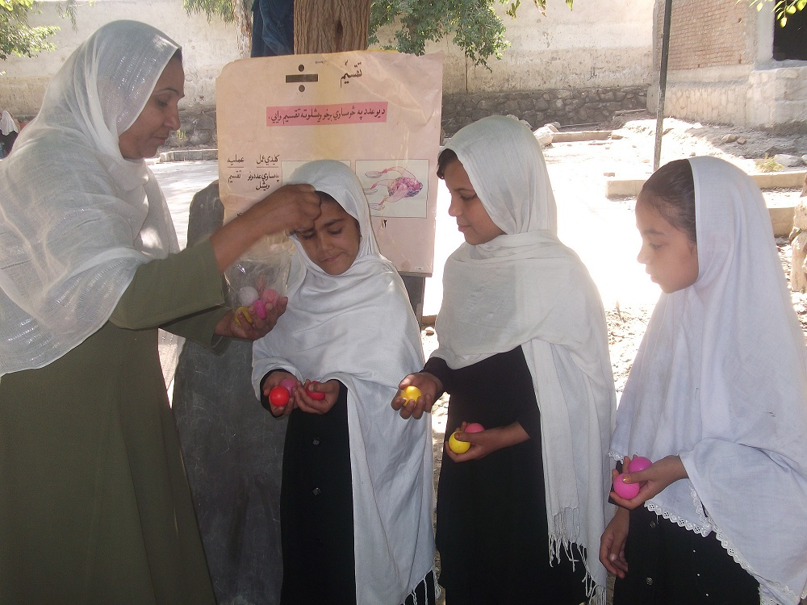
3rd grade Teacher Miss Mahjabeen teaches division sum and uses balls
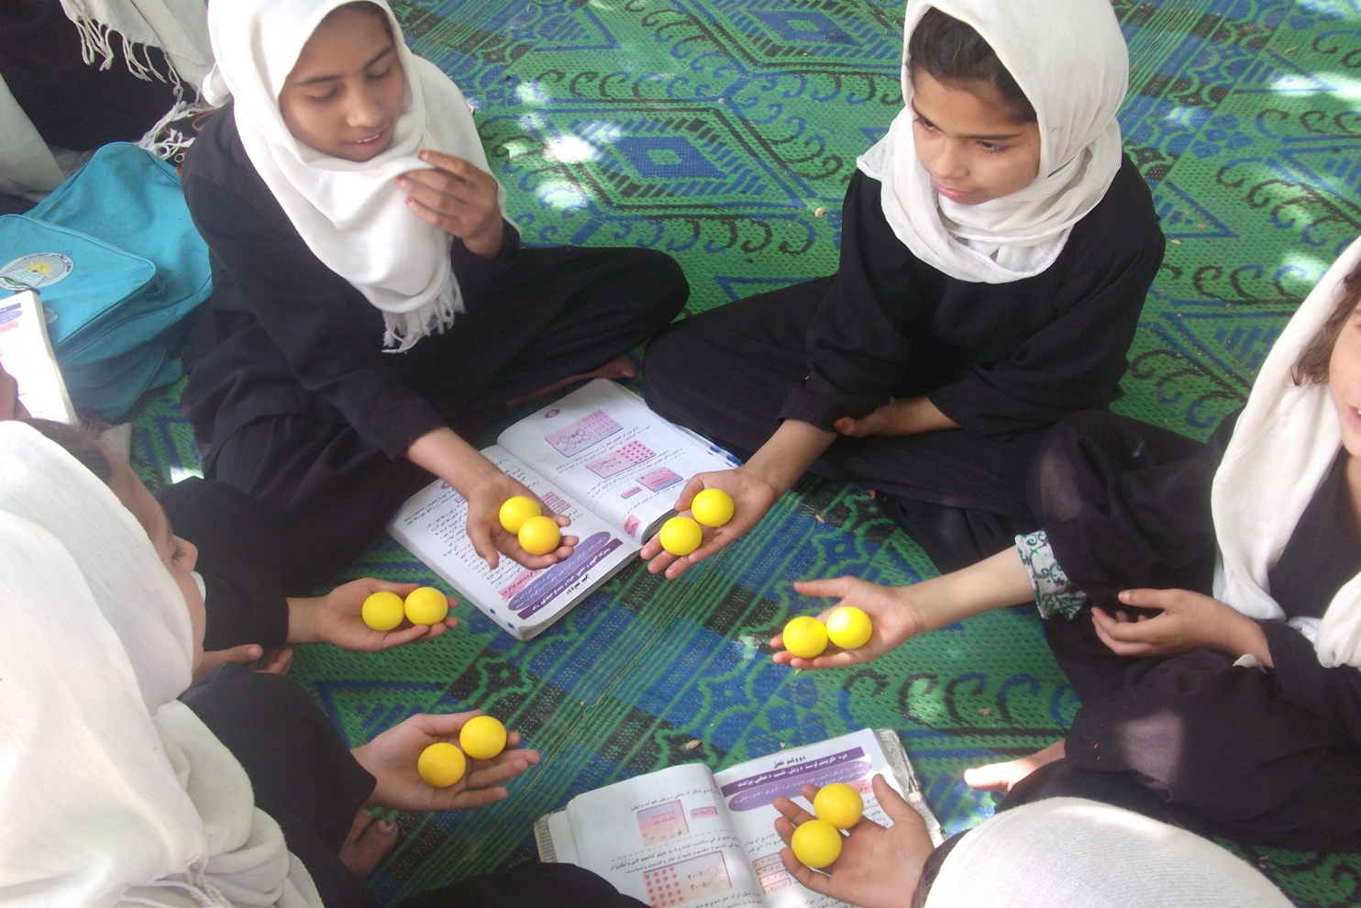
The 3rd grade students use balls to practice solving division sum.

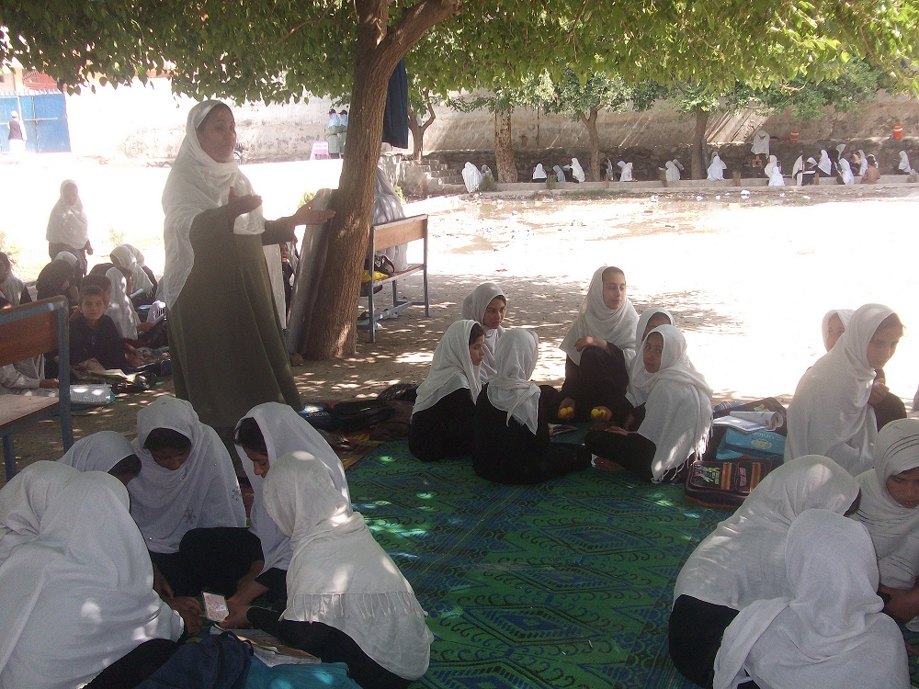Students receive instruction on how to use teaching materials during group work.

Home Work:
Students in Aghan school rarely do homework in Afghan schools. Reducing this challenge , the Nasrat II school teachers learned how to motivate students to work on their assignments at home. For this, the teachers were advised to change the very old method of punishment to motivation. Most teachers did not believe if motivation will work better than punishment, but their belief proved wrong when Miss Babugul used color stickers as appreciation for those who did homework.g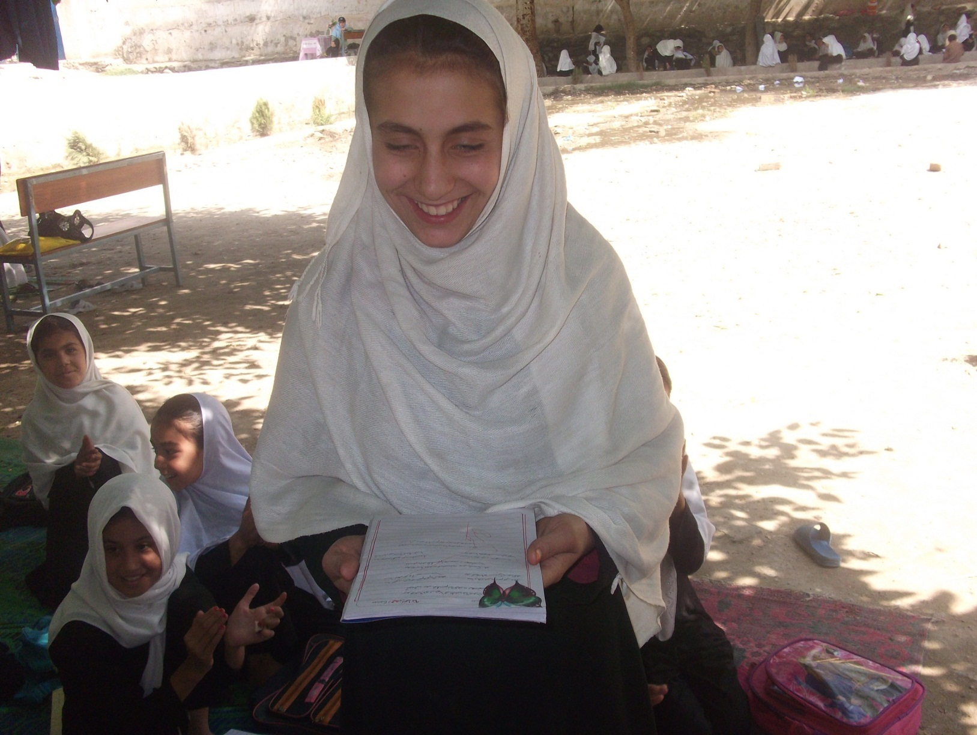A 3rd grade student Shukrya received butterfly sticker for her good homework.

The End

